Tenant
A tenant in the Power Platform refers to an organization or entity that uses the platform’s services.

Environment Basics
An environment in the context of Dataverse is like a container or workspace where you organize and store your business data.
An environment also allows you to install applications that you build with Power Apps or flows that you create with Power Automate into that environment. You can create one or many environments, depending on your needs.
Each environment is created under a Microsoft Entra ID tenant, and only users within that tenant can access its resources. An environment is also bound to a geographic location, like the United States

Resource Access:
  - Resources (such as Dataverse databases, connections, flows, etc.) created within an environment are accessible only within that environment.
  - However, resources from one environment cannot directly access resources in another environment within the same tenant.

Sharing Data Across Different Environments/Region:
Data Integration Tools: Use tools like Azure Data Factory or Power Automate to create data pipelines that can move data between environments in different geographic locations.
APIs and Connectors: Utilize APIs and connectors available in Power Platform to facilitate data sharing. For example, you can create flows in Power Automate that connect to Dataverse databases in both environments.
Cross-Region Replication: If your data needs to be highly available and synchronized in real-time, consider setting up cross-region replication. This can be done using Azure SQL Database or Cosmos DB, which support geo-replication.

Data Flows
Purpose: Data Flows are used for data preparation and transformation. They allow you to ingest, cleanse, transform, and load data into Dataverse, Power BI, or Azure Data Lake Storage.
Execution: Data Flows are created using Power Query, which provides a graphical interface for building transformation logic. They run in the cloud and can be scheduled to refresh automatically.

Flows
Purpose: Flows, created in Power Automate, are used to automate workflows and business processes. They help in connecting different services and automating repetitive tasks.
Execution: Flows are triggered by events, such as receiving an email, a new file being added to a folder, or a specific time of day.
Usage: Commonly used for automating tasks like sending notifications, updating records, or collecting data from various sources.

Inside Security Roles:

Table Privileges:
    - These define what tasks a user can perform on specific records within a table.
    - Examples include Read, Create, Delete, Write, Assign, Share, Append, and

Append To.
    - For instance, a salesperson might have Read access to customer records but can also Create new opportunities

Miscellaneous Privileges:
These task-based privileges allow users to perform specific non-record tasks.

Examples include publishing articles, activating business rules/process flow, bulk delete, bulk edit, enable or disable user.

  - Privacy-Related Privileges:
These permissions relate specifically to data integration, export, or printing.
Users with these privileges can export to Excel, print records, or use other privacy- related

Business Rule
A business rule refers to a set of logical conditions and actions that are applied to data entry forms or views.

Scope of Business Rule:
    - I⭲di:id"al Ioíms
    - All Ioíms
    - E⭲titQ

Actions:
    - Set column values.
    - Clear column values.
    - Set column requirement levels.
    - Show or hide columns.
    - Enable or disable columns.
    - Validate data and show error messages.

Calculated Field
A rich conditional support provides branching and multiple conditions. The logical operations include AND and OR operators.
The visual editing capabilities include modern user interface and intellisense in the ACTION section.

Some build-in functions include
ADDHOURS, ADDDAYS, ADDWEEKS, ADDMONTHS, ADDYEARS, SUBTRACTHOU RS, SUBTRACTDAYS, SUBTRACTWEEKS, SUBTRACTMONTHS, SUBTRACTYEARS, DIFFINDAYS, DIFFINHOURS, DIFFINMINUTES, DIFFINMONTHS, DIFFINWEEKS, D IFFINYEARS, CONCAT, TRIMLEFT, and TRIMRIGHT.
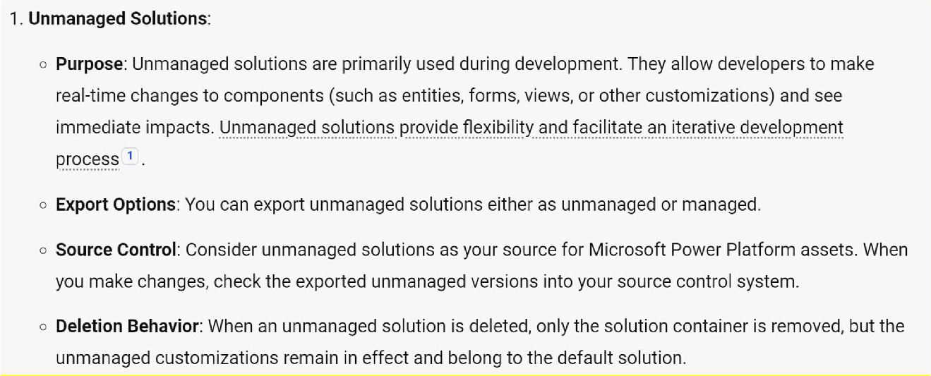
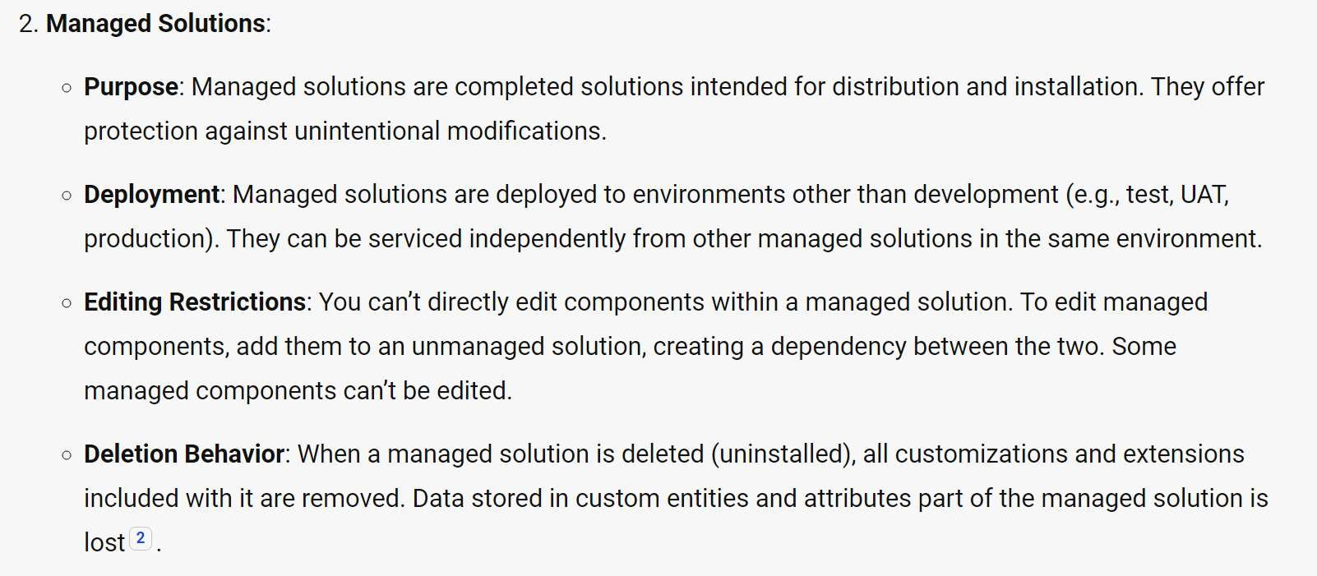


Calculated Field Scope
    - Single line of text
    - Option Set
    - Two Options
    - Whole Number
    - Decimal Number
    - Currency
    - Date and Time
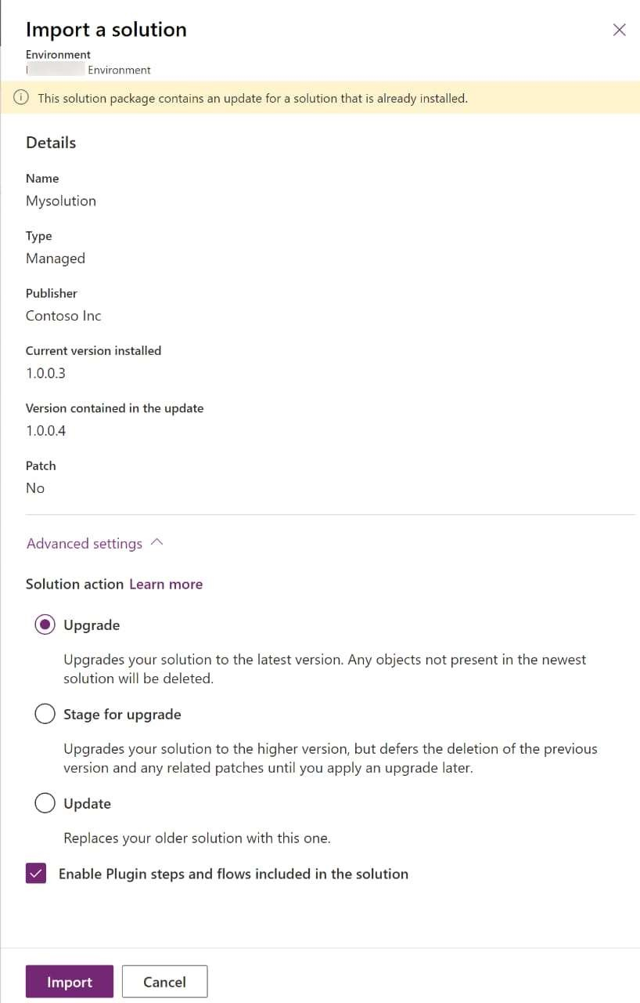
Appc⭲d a⭲d Appc⭲d ľo

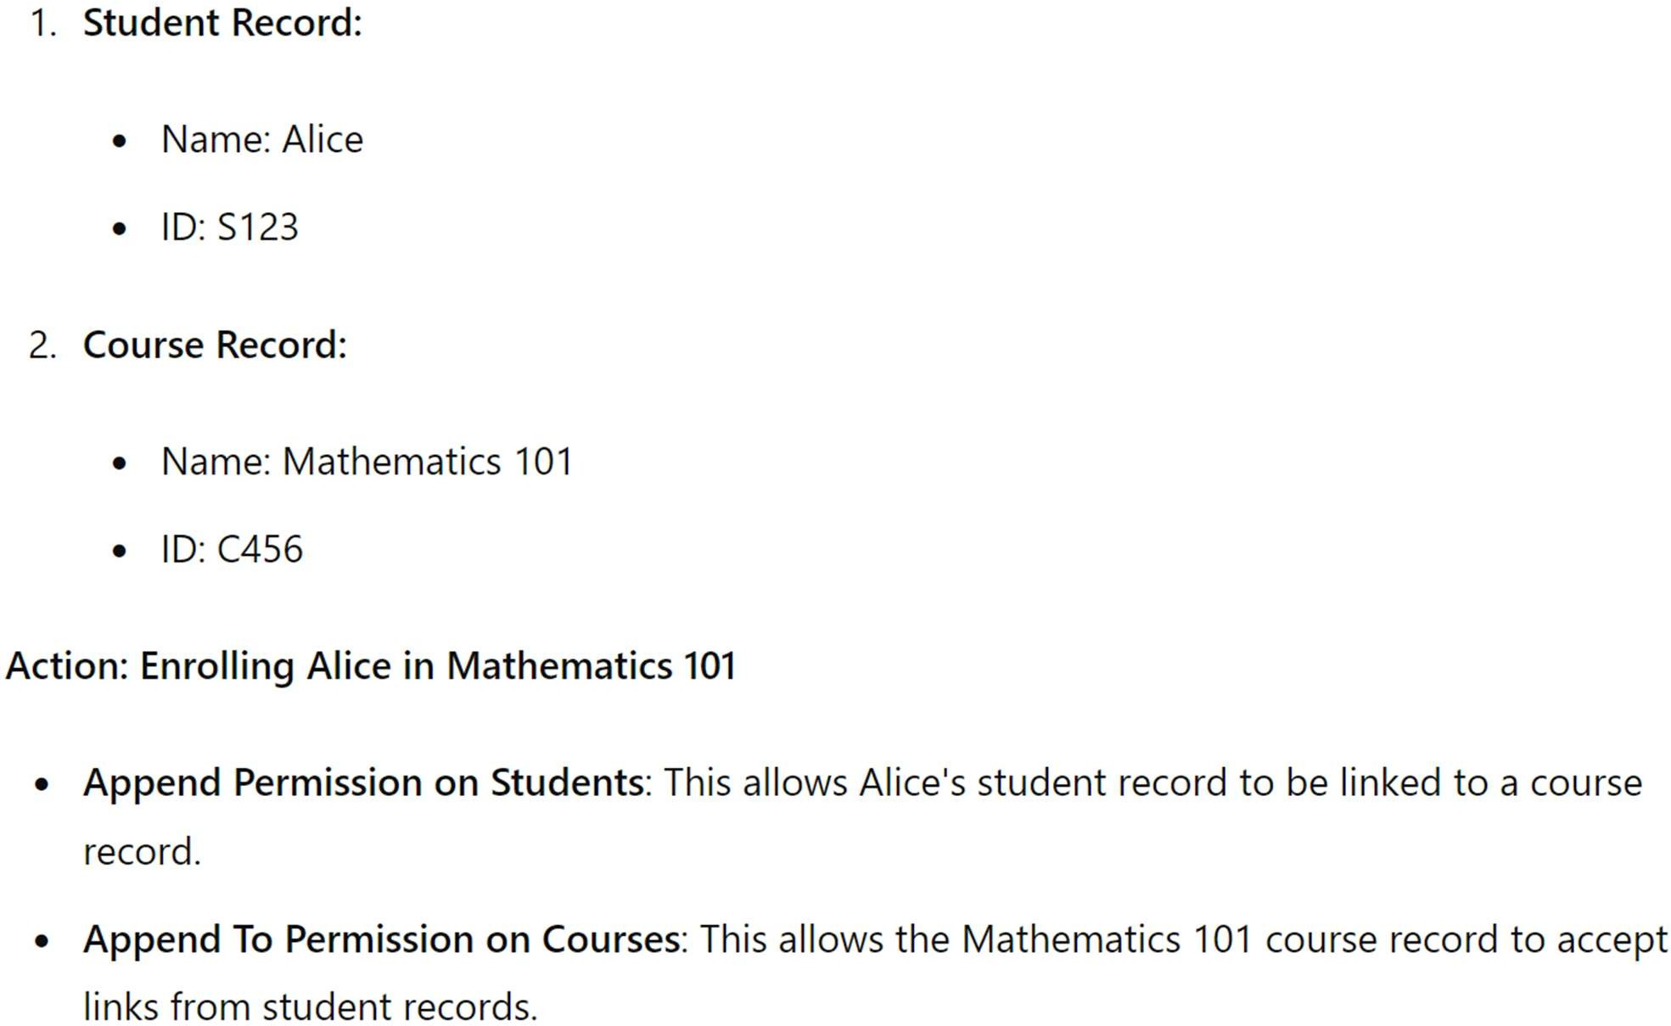

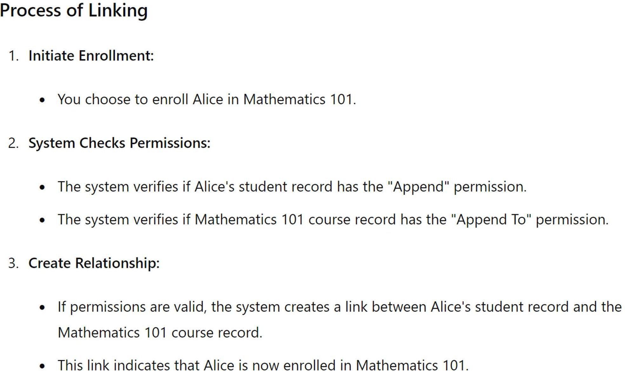
Views
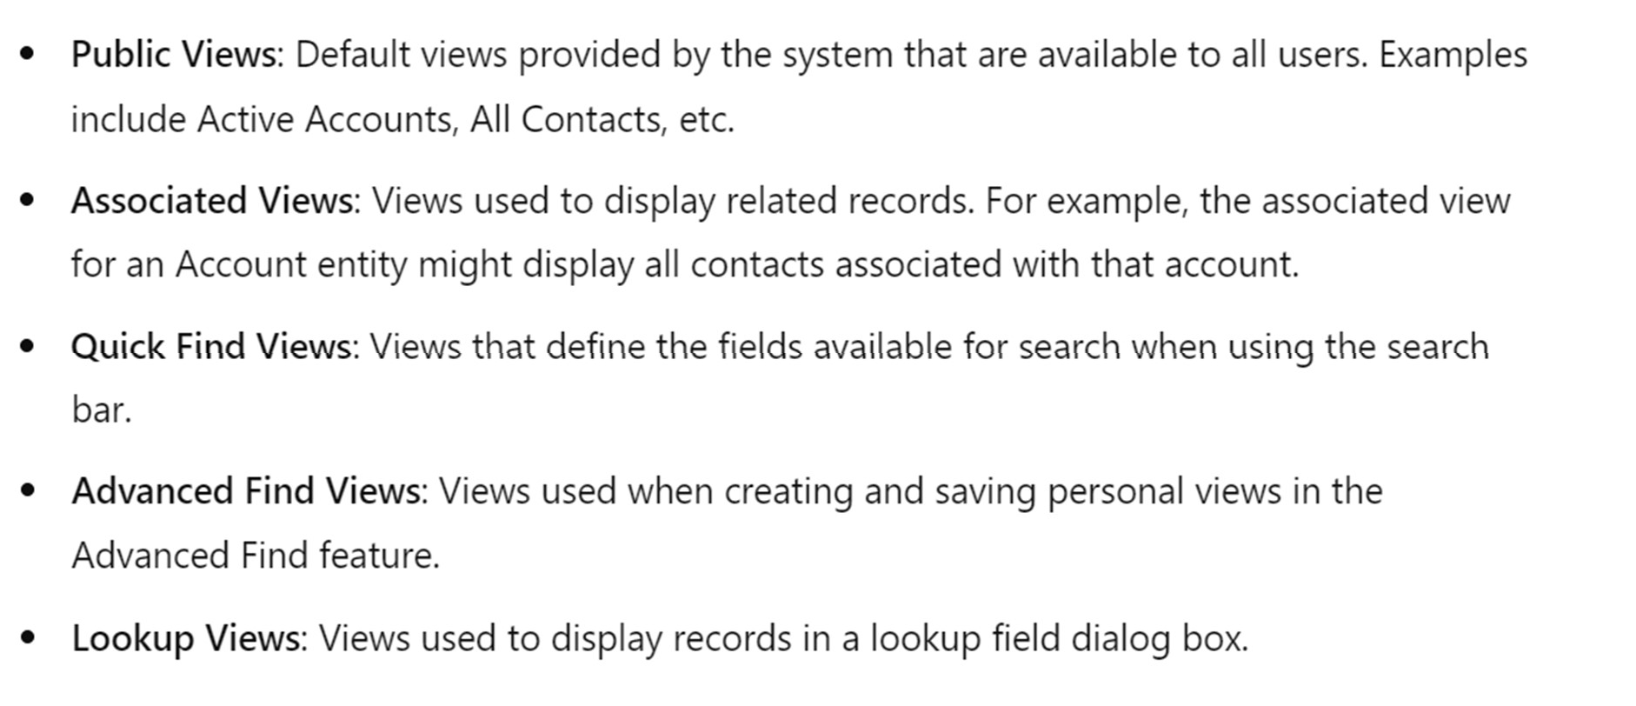

Why we use Data Process
Business Process Flows (BPF) in Power Apps are used to guide users through a defined set of steps in a process to ensure data consistency and efficiency in business operations
.

